Министерство образования и молодежной политики Свердловской области

ГАПОУ СО «Екатеринбургский колледж транспортного строительства»

Отчет по ТРПО. Лабораторная работа №6  
**«Триггеры в WPF-приложениях».**

Выполнил: Гордейчик С.А.

Группа: ПР-31

Преподаватель: Бушуева Е.В.

2024

Разметка (задание 1):

<Window x:Class="Triggers.MainWindow"

xmlns="http://schemas.microsoft.com/winfx/2006/xaml/presentation"

xmlns:x="http://schemas.microsoft.com/winfx/2006/xaml"

xmlns:d="http://schemas.microsoft.com/expression/blend/2008"

xmlns:mc="http://schemas.openxmlformats.org/markup-compatibility/2006"

xmlns:local="clr-namespace:Triggers"

WindowStartupLocation="CenterScreen"

mc:Ignorable="d"

Title="Triggers" Height="450" Width="800">

<Window.Resources>

<Style TargetType="Button">

<Style.Triggers>

<Trigger Property="IsMouseOver" Value="True">

<Trigger.Setters>

<Setter Property="FontSize" Value="20"/>

</Trigger.Setters>

</Trigger>

</Style.Triggers>

</Style>

</Window.Resources>

<StackPanel Orientation="Horizontal" VerticalAlignment="Top" Margin="5">

<Button>Открыть</Button>

<Button>Обработать</Button>

<Button>Сохранить</Button>

<Button>Закрыть</Button>

</StackPanel>

</Window>

Снимок экрана (задание 1):

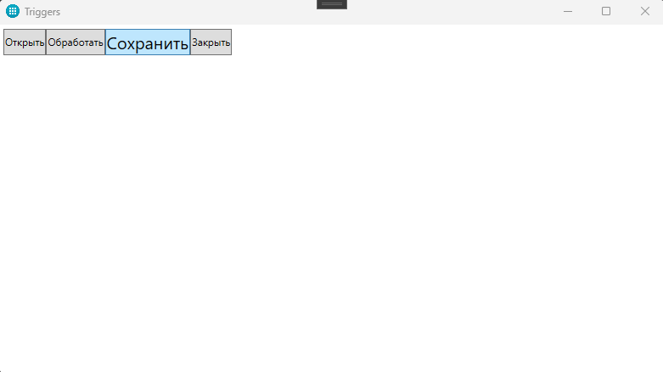

Разметка (задание 2):

<Window x:Class="Triggers_Task.MainWindow"

xmlns="http://schemas.microsoft.com/winfx/2006/xaml/presentation"

xmlns:x="http://schemas.microsoft.com/winfx/2006/xaml"

xmlns:d="http://schemas.microsoft.com/expression/blend/2008"

xmlns:mc="http://schemas.openxmlformats.org/markup-compatibility/2006"

xmlns:local="clr-namespace:Triggers_Task"

WindowStartupLocation="CenterScreen"

mc:Ignorable="d"

Title="Triggers" Height="450" Width="800">

<Window.Resources>

<local:MultiBoolConverter x:Key="MultiBoolConverter"/>

<Style x:Key="ButtonStyle" TargetType="Button">

<Setter Property="Margin" Value="5"/>

<Setter Property="FontFamily" Value="Arial"/>

<Setter Property="FontSize" Value="12"/>

<Setter Property="Width" Value="70"/>

<Setter Property="Background" Value="#FFDDDDDD"/>

<Setter Property="Foreground" Value="Black"/>

<Setter Property="BorderBrush" Value="Black"/>

<Setter Property="Template">

<Setter.Value>

<ControlTemplate TargetType="Button">

<Border Background="{TemplateBinding Background}"

BorderBrush="{TemplateBinding BorderBrush}"

BorderThickness="{TemplateBinding BorderThickness}"

CornerRadius="5">

<ContentPresenter HorizontalAlignment="Center"

VerticalAlignment="Center"/>

</Border>

<ControlTemplate.Triggers>

<Trigger Property="IsMouseOver" Value="True">

<Setter Property="Background" Value="#FFAAAAAA"/>

</Trigger>

<Trigger Property="IsPressed" Value="True">

<Setter Property="Background" Value="#FF888888"/>

</Trigger>

</ControlTemplate.Triggers>

</ControlTemplate>

</Setter.Value>

</Setter>

</Style>

<Style x:Key="TextBoxStyle" TargetType="TextBox">

<Setter Property="Margin" Value="5"/>

<Setter Property="FontFamily" Value="Arial"/>

<Setter Property="FontSize" Value="12"/>

<Setter Property="Foreground" Value="Black"/>

<Setter Property="Background">

<Setter.Value>

<LinearGradientBrush StartPoint="0,0" EndPoint="1,0">

<GradientStop Color="#FFCCE5FF" Offset="0"/>

<GradientStop Color="#FF99CCFF" Offset="1"/>

</LinearGradientBrush>

</Setter.Value>

</Setter>

<Style.Triggers>

<DataTrigger Binding="{Binding ElementName=comboBox, Path=SelectedIndex}" Value="1">

<Setter Property="FontSize" Value="16"/>

</DataTrigger>

<DataTrigger Binding="{Binding ElementName=comboBox, Path=SelectedIndex}" Value="2">

<Setter Property="FontStyle" Value="Italic"/>

</DataTrigger>

</Style.Triggers>

</Style>

</Window.Resources>

<Grid>

<Grid.RowDefinitions>

<RowDefinition Height="Auto"/>

<RowDefinition Height="*"/>

<RowDefinition Height="*"/>

<RowDefinition Height="40"/>

</Grid.RowDefinitions>

<ComboBox Grid.Row="0" x:Name="comboBox" HorizontalAlignment="Left" Margin="5" SelectedIndex="0">

<ComboBoxItem Content="Стандартный"/>

<ComboBoxItem Content="Крупный"/>

<ComboBoxItem Content="Курсив"/>

</ComboBox>

<TextBox Grid.Row="1" x:Name="textBox1" Style="{StaticResource TextBoxStyle}" AcceptsReturn="True" VerticalScrollBarVisibility="Visible"/>

<TextBox Grid.Row="2" x:Name="textBox2" Style="{StaticResource TextBoxStyle}" AcceptsReturn="True" VerticalScrollBarVisibility="Visible"/>

<StackPanel Grid.Row="3" Orientation="Horizontal" HorizontalAlignment="Center">

<Button Content="Открыть" Style="{StaticResource ButtonStyle}"/>

<Button Content="Очистить" Click="ClearButton_Click" Style="{StaticResource ButtonStyle}"/>

<Button Content="Закрыть" Click="CloseCommand_Executed" Style="{StaticResource ButtonStyle}">

<Button.IsEnabled>

<MultiBinding Converter="{StaticResource MultiBoolConverter}">

<Binding ElementName="textBox1" Path="Text"/>

<Binding ElementName="textBox2" Path="Text"/>

</MultiBinding>

</Button.IsEnabled>

</Button>

</StackPanel>

</Grid>

</Window>

Код (задание 2):

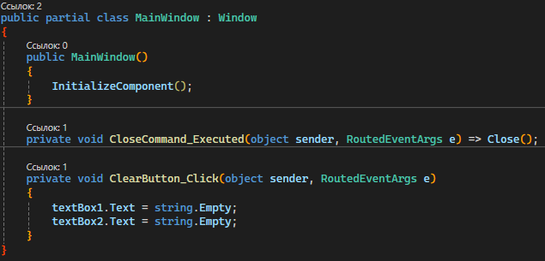

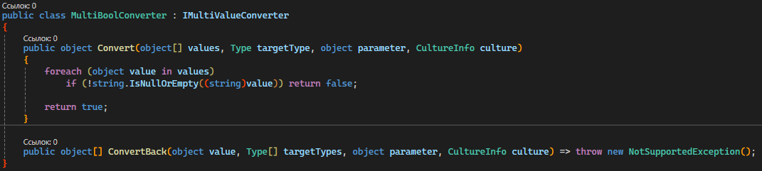

Снимок экрана (задание 2):

